SPECIFICATION OF COCOBRISTLE
Issue No. | 01 | Issue Date | 29.07.2025 | BRN/PR/SP/03
Revision No. | 00 | Revision Date | 00 | Page | 1 of 19

Name of Product | Cocobristle
Raw Material Source | From the fresh green coconut husk
Origin Plant Source | Coconut/Coco Nucifera
Length (cm) | 20 cm
Fibre/impurities (w/w) | Max 2.0 %
Moisture % (w/w) | 15±5%
Product Type | Bristle
Packing | Sack
Price | $ 6,35 / 4 bunchess (1 kg)
Product Images

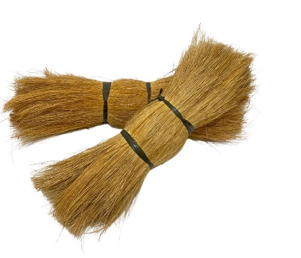
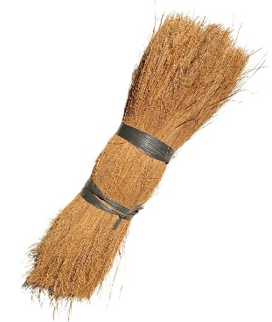
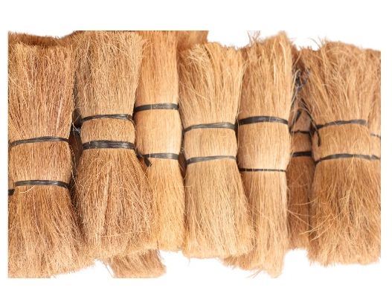

SPECIFICATION OF HIGH EC COCOPEAT BLOCKS
Issue No. | 02 | Issue Date | 29.07.2025 | BRN/PR/SP/03
Revision No. | 00 | Revision Date | 00 | Page | 2 of 19

Name of Product | Cocopeat Block
Raw Material Source | From the fresh green coconut husk
Origin Plant Source | Coconut/Coco Nucifera
Dimensions (cm) | 30 x 30 x 15 ± 3
Fibre/impurities (w/w) | Max 2.0 %
Moisture % (w/w) | 15±5%
Product Type | Block / Pressed Block
Product Density | 460 kg /m³
Packing | Wrapping with plastic & on the wooden pallets
Blocks qty on the pallet | 1890 Blocks
Weight of the Pallet (Net) | 850 ± 5% kg
Electric Conductivity | EC < 1000 µ/cm. High EC
pH | 5.5 to 7.0
Price | $ 5,3 / pcs
Product Images

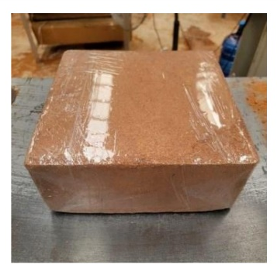
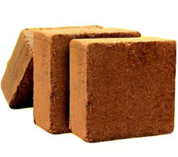

SPECIFICATION OF LOW EC COCOPEAT BLOCKS
Issue No. | 03 | Issue Date | 29.07.2025 | BRN/PR/SP/03
Revision No. | 00 | Revision Date | 00 | Page | 3 of 19

Name of Product | Cocopeat Block
Raw Material Source | From the fresh green coconut husk
Origin Plant Source | Coconut/Coco Nucifera
Dimensions (cm) | 30 x 30 x 15 ± 3
Fibre/impurities (w/w) | Max 2.0 %
Moisture % (w/w) | 15±5%
Product Type | Block / Pressed Block
Product Density | 460 kg /m³
Packing | Wrapping with plastic & on the wooden pallets
Blocks qty on the pallet | 1890 Blocks
Weight of the Pallet (Net) | 850 ± 5% kg
Electric Conductivity | EC > 0.5 µ/m. Low EC
pH | 5.5 to 7.0
Price | $ 5,5 / pcs
Product Images

SPECIFICATION OF COCOROPE (4 mm)
Issue No. | 04 | Issue Date | 29.07.2025 | BRN/PR/SP/03
Revision No. | 00 | Revision Date | 00 | Page | 4 of 19

Name of Product | Cocorope
Raw Material Source | 100% natural coconut fiber (coir)
Origin Plant Source | Coconut/Coco Nucifera
Diameters (mm) | 4 mm
Fibre/impurities (w/w) | Max 2.0 %
Moisture % (w/w) | 15±5%
Length per Coil | 65 m
Product Type | Rope
Packaging | Plastic Wrap
Price | $ 4,6 / coil
Product Images

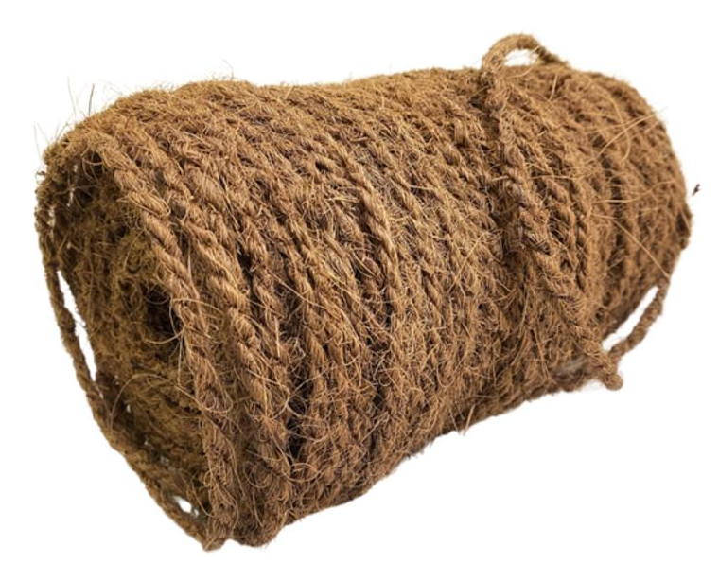

SPECIFICATION OF COCOROPE (6 mm)
Issue No. | 05 | Issue Date | 29.07.2025 | BRN/PR/SP/03
Revision No. | 00 | Revision Date | 00 | Page | 5 of 19

Name of Product | Cocorope
Raw Material Source | 100% natural coconut fiber (coir)
Origin Plant Source | Coconut/Coco Nucifera
Diameters (mm) | 4 mm
Fibre/impurities (w/w) | Max 2.0 %
Moisture % (w/w) | 15±5%
Length per Coil | 65 m
Product Type | Rope
Packing | Plastic Wrap
Price | $ 5,4 / coil
Product Images

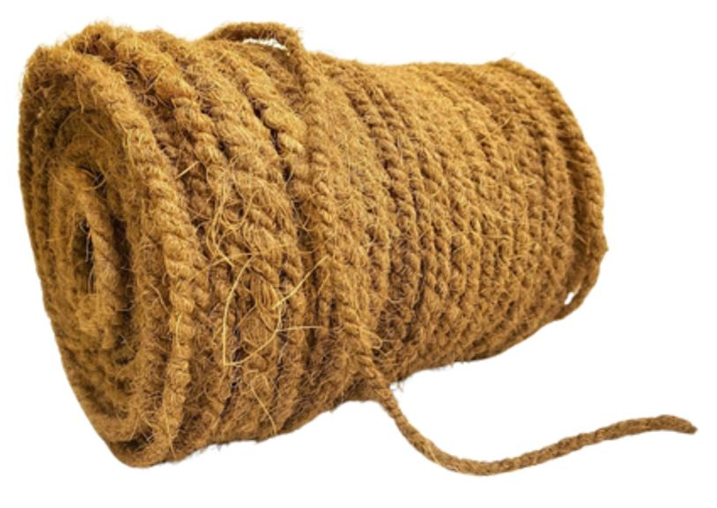

SPECIFICATION OF COCOROPE (8 mm)
Issue No. | 06 | Issue Date | 29.07.2025 | BRN/PR/SP/03
Revision No. | 00 | Revision Date | 00 | Page | 6 of 19

Name of Product | Cocorope
Raw Material Source | 100% natural coconut fiber (coir)
Origin Plant Source | Coconut/Coco Nucifera
Diameters (mm) | 4 mm
Fibre/impurities (w/w) | Max 2.0 %
Moisture % (w/w) | 15±5%
Length per Coil | 65 m
Product Type | Rope
Packing | Plastic Wrap
Price | $ 5,7 / coil
Product Images

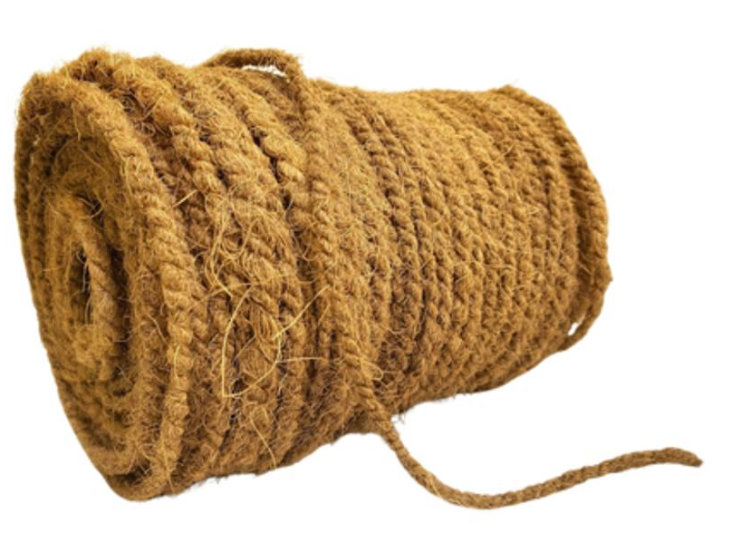

SPECIFICATION OF COCOROPE (20 mm)
Issue No. | 07 | Issue Date | 29.07.2025 | BRN/PR/SP/03
Revision No. | 00 | Revision Date | 00 | Page | 7 of 19

Name of Product | Cocorope
Raw Material Source | 100% natural coconut fiber (coir)
Origin Plant Source | Coconut/Coco Nucifera
Diameters (mm) | 4 mm
Fibre/impurities (w/w) | Max 2.0 %
Moisture % (w/w) | 15±5%
Length per Coil | 65 m
Product Type | Rope
Packing | Plastic Wrap
Price | $ 22,6 / coil
Product Images

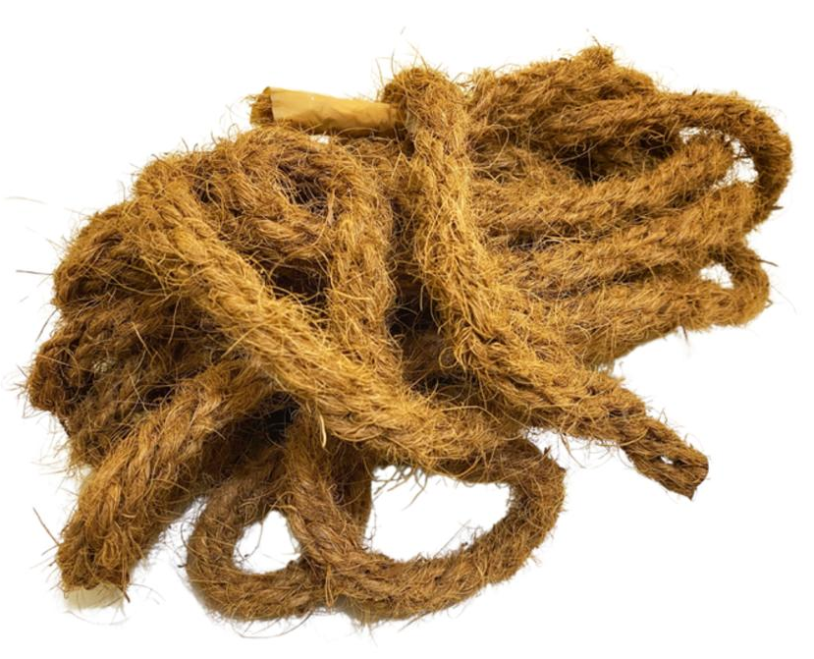

SPECIFICATION OF LARGE POLYGON COCOPOT
Issue No. | 08 | Issue Date | 29.07.2025 | BRN/PR/SP/03
Revision No. | 00 | Revision Date | 00 | Page | 8 of 19

Name of Product | Cocopot
Raw Material Source | From 100% natural coconut coir fiber and natural latex as a binding agent.
Origin Plant Source | Coconut/Coco Nucifera
Top Diameters (cm) | 21 cm
Bottom Diameters (cm) | 11.5 cm
Fibre/impurities (w/w) | Max 2.0 %
Moisture % (w/w) | 15±5%
Product Type | Pot
Packing | Box or customized packing available
Price | $ 3,69 / pcs
Product Images

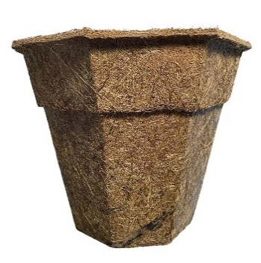
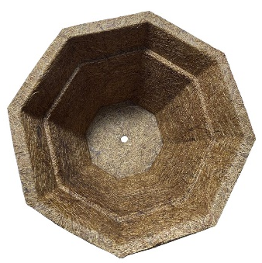

SPECIFICATION OF MEDIUM POLYGON COCOPOT
Issue No. | 09 | Issue Date | 29.07.2025 | BRN/PR/SP/03
Revision No. | 00 | Revision Date | 00 | Page | 9 of 19

Name of Product | Cocopot
Raw Material Source | From 100% natural coconut coir fiber and natural latex as a binding agent.
Origin Plant Source | Coconut/Coco Nucifera
Top Diameters (cm) | 21 cm
Bottom Diameters (cm) | 11.5 cm
Height | 18 cm
Color | Natural Brown
Fibre/impurities (w/w) | Max 2.0 %
Moisture % (w/w) | 15±5%
Product Type | Pot
Packing | Bulk or customized packing available
Price | $ 3,19 / pcs
Product Images

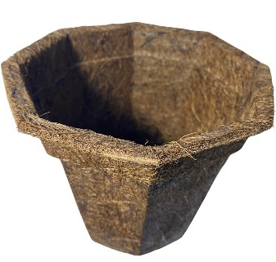
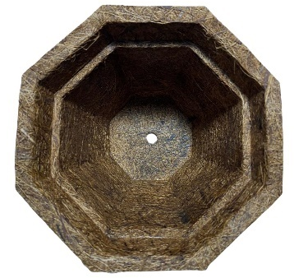

SPECIFICATION OF SMALL SEMI POLYGON COCOPOT
Issue No. | 10 | Issue Date | 29.07.2025 | BRN/PR/SP/03
Revision No. | 00 | Revision Date | 00 | Page | 10 of 19

Name of Product | Cocopot
Raw Material Source | From 100% natural coconut coir fiber and natural latex as a binding agent.
Origin Plant Source | Coconut/Coco Nucifera
Top Diameters (cm) | 13.5 cm
Bottom Diameters (cm) | 8 cm
Height | 11 cm
Color | Natural Brown
Fibre/impurities (w/w) | Max 2.0 %
Moisture % (w/w) | 15±5%
Product Type | Pot
Packing | Box or customized packing available
Price | $ 3,19 / pcs
Product Images

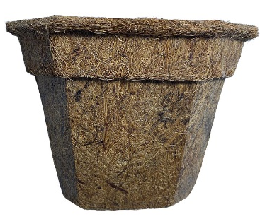
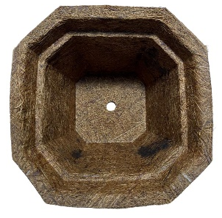

SPECIFICATION OF LARGE ROUND COCOPOT
Issue No. | 11 | Issue Date | 29.07.2025 | BRN/PR/SP/03
Revision No. | 00 | Revision Date | 00 | Page | 11 of 19

Name of Product | Cocopot
Raw Material Source | From 100% natural coconut coir fiber and natural latex as a binding agent.
Origin Plant Source | Coconut/Coco Nucifera
Top Diameters (cm) | 21 cm
Bottom Diameters (cm) | 11.5 cm
Height | 18 cm
Color | Natural Brown
Fibre/impurities (w/w) | Max 2.0 %
Moisture % (w/w) | 15±5%
Product Type | Pot
Packing | Box or customized packing available
Price | $ 3,69 / pcs
Product Images

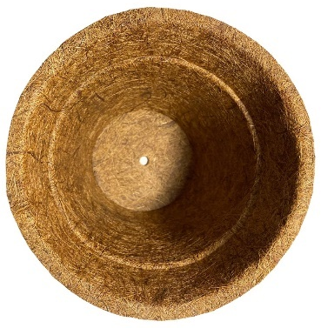
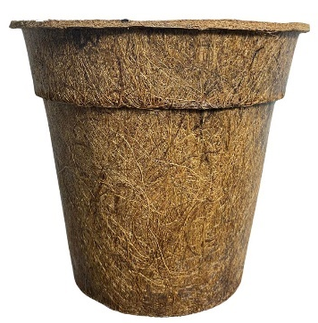

SPECIFICATION OF MEDIUM ROUND COCOPOT
Issue No. | 12 | Issue Date | 29.07.2025 | BRN/PR/SP/03
Revision No. | 00 | Revision Date | 00 | Page | 12 of 19

Name of Product | Cocopot
Raw Material Source | From 100% natural coconut coir fiber and natural latex as a binding agent.
Origin Plant Source | Coconut/Coco Nucifera
Top Diameters (cm) | 13.5 cm
Bottom Diameters (cm) | 8 cm
Height | 11 cm
Color | Natural Brown
Fibre/impurities (w/w) | Max 2.0 %
Moisture % (w/w) | 15±5%
Product Type | Pot
Packing | Box or customized packing available
Price | $ 3,19 / pcs
Product Images

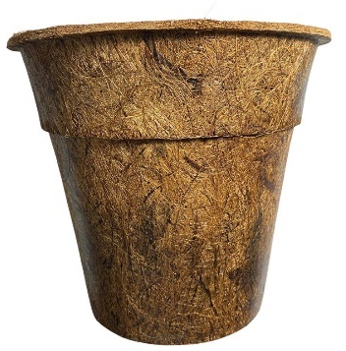
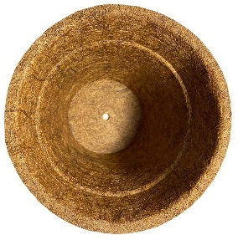

SPECIFICATION OF SMALL SEMI ROUND COCOPOT
Issue No. | 13 | Issue Date | 29.07.2025 | BRN/PR/SP/03
Revision No. | 00 | Revision Date | 00 | Page | 13 of 19

Name of Product | Cocopot
Raw Material Source | From 100% natural coconut coir fiber and natural latex as a binding agent.
Origin Plant Source | Coconut/Coco Nucifera
Top Diameters (cm) | 13.5 cm
Bottom Diameters (cm) | 8 cm
Height | 11 cm
Color | Natural Brown
Fibre/impurities (w/w) | Max 2.0 %
Moisture % (w/w) | 15±5%
Product Type | Pot
Packing | Box or customized packing available
pH | 5.5 to 7.0
Price | $ 3,19 / pcs
Product Images

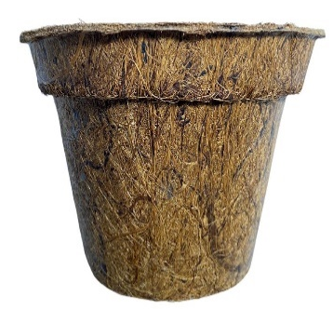
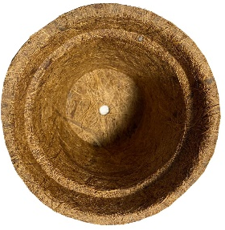

SPECIFICATION OF SMALL ROUND COCOPOT
Issue No. | 14 | Issue Date | 29.07.2025 | BRN/PR/SP/03
Revision No. | 00 | Revision Date | 00 | Page | 14 of 19

Name of Product | Cocopot
Raw Material Source | From 100% natural coconut coir fiber and natural latex as a binding agent.
Origin Plant Source | Coconut/Coco Nucifera
Top Diameters (cm) | 13.5 cm
Bottom Diameters (cm) | 8 cm
Height | 11 cm
Color | Natural Brown
Fibre/impurities (w/w) | Max 2.0 %
Moisture % (w/w) | 15±5%
Product Type | Pot
Packing | Box or customized packing available
Price | $ 2,81 / pcs
Product Images

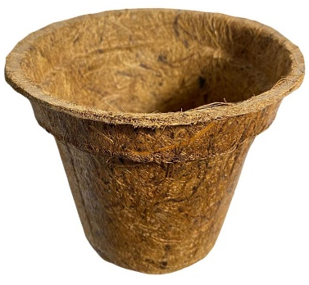
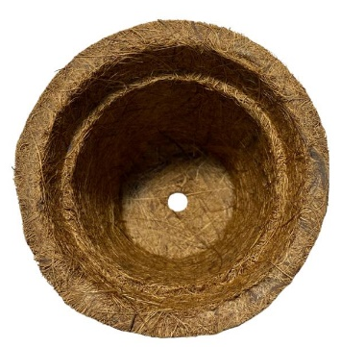

SPECIFICATION OF COCOMAT BINCO STRIP
Issue No. | 15 | Issue Date | 29.07.2025 | BRN/PR/SP/03
Revision No. | 00 | Revision Date | 00 | Page | 15 of 19

Name of Product | Cocomat
Raw Material Source | From 100% natural coconut coir
Origin Plant Source | Coconut/Coco Nucifera
Length | 90 cm
Width | 45 cm
Thickness | 3 cm
Color | Natural Brown
Fibre/impurities (w/w) | Max 2.0 %
Moisture % (w/w) | 15±5%
Product Type | Mat
Packing | Customized packing available
Price | 4,19 / pcs
Product Images

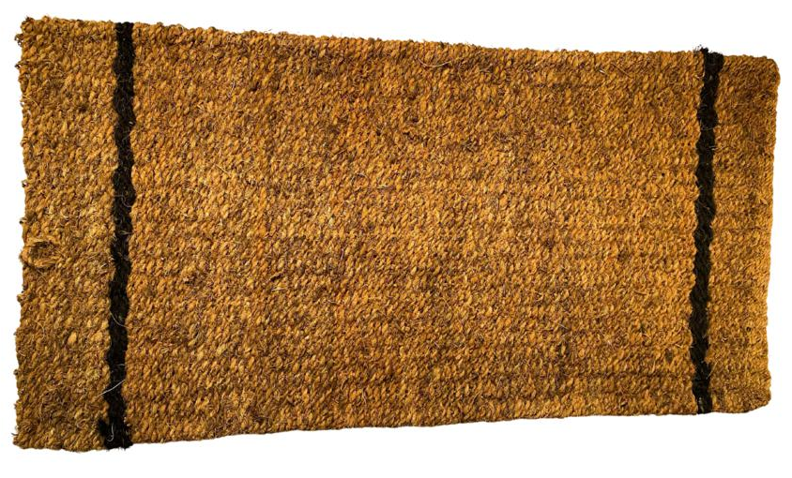

SPECIFICATION OF PREMIUM BINCO COCOMAT
Issue No. | 16 | Issue Date | 29.07.2025 | BRN/PR/SP/03
Revision No. | 00 | Revision Date | 00 | Page | 16 of 19

Name of Product | Cocomat
Raw Material Source | From 100% natural coconut coir
Origin Plant Source | Coconut/Coco Nucifera
Length | 40 cm
Width | 60 cm
Thickness | 5 cm
Color | Natural Brown
Fibre/impurities (w/w) | Max 2.0 %
Moisture % (w/w) | 15±5%
Product Type | Doormat
Packing | Customized packing available
Price | $ 4,19 / pcs
Product Images
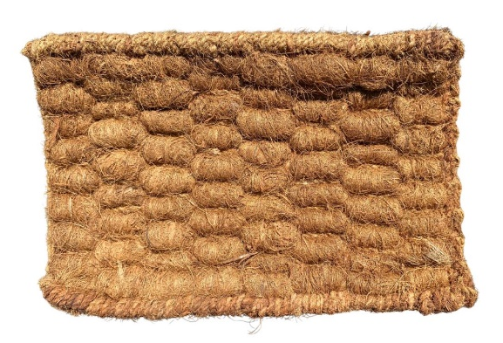
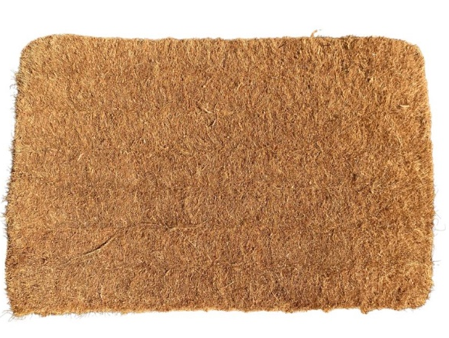

SPECIFICATION OF PREMIUM BINCO WELCOME COCOMAT
Issue No. | 17 | Issue Date | 29.07.2025 | BRN/PR/SP/03
Revision No. | 00 | Revision Date | 00 | Page | 17 of 19

Name of Product | Cocomat
Raw Material Source | From 100% natural coconut coir
Origin Plant Source | Coconut/Coco Nucifera
Length | 100 cm
Width | 50 cm
Thickness | 5 cm
Color | Natural Brown
Fibre/impurities (w/w) | Max 2.0 %
Moisture % (w/w) | 15±5%
Product Type | Mat
Packing | Customized packing available
Price | $ 7,81 / pcs
Product Images

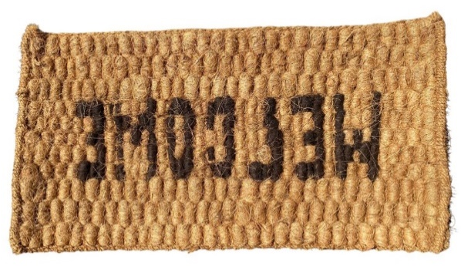

SPECIFICATION OF LOW-PRICE PREMIUM BINCO WELCOME COCOMAT 90X45
Issue No. | 18 | Issue Date | 29.07.2025 | BRN/PR/SP/03
Revision No. | 00 | Revision Date | 00 | Page | 18 of 19

Name of Product | Cocomat
Raw Material Source | From 100% natural coconut coir
Origin Plant Source | Coconut/Coco Nucifera
Length | 90 cm
Width | 45 cm
Thickness | 4 cm
Color | Natural Brown
Fibre/impurities (w/w) | Max 2.0 %
Moisture % (w/w) | 15±5%
Product Type | Doormat
Packing | Customized packing available
Price | $ 5,36 / pcs
Product Images

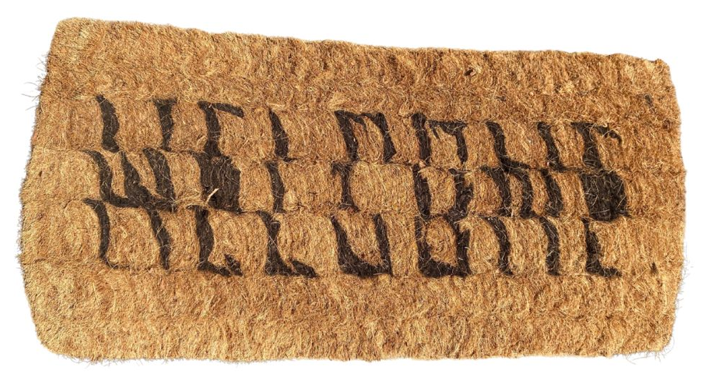

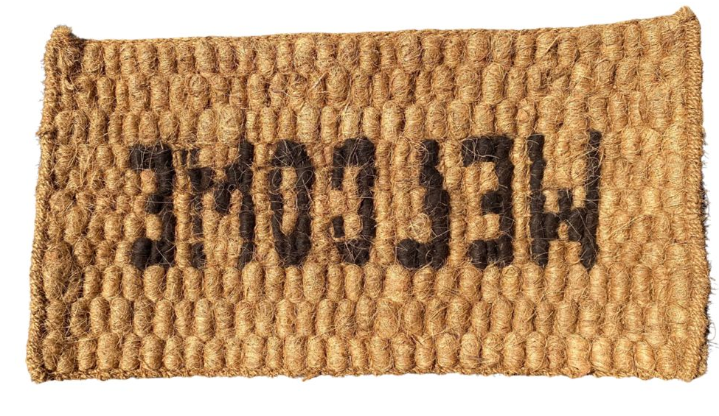

SPECIFICATION OF W-PRICE PREMIUM BINCO WELCOME COCOMAT 150X45
Issue No. | 19 | Issue Date | 29.07.2025 | BRN/PR/SP/03
Revision No. | 00 | Revision Date | 00 | Page | 19 of 19

Name of Product | Cocomat
Raw Material Source | From 100% natural coconut coir
Origin Plant Source | Coconut/Coco Nucifera
Length | 150 cm
Width | 45 cm
Thickness | 4 cm
Color | Natural Brown
Fibre/impurities (w/w) | Max 2.0 %
Moisture % (w/w) | 15±5%
Product Type | Doormat
Packing | Customized packing available
Price | $ 5,31 / pcs
Product Images

